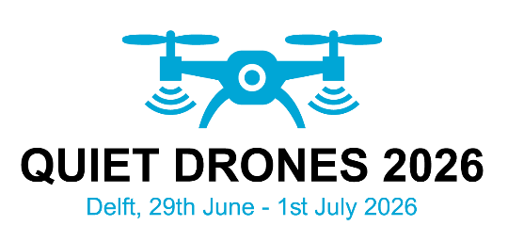
Title of your Quiet Drones 2026 abstract

First A. Author*, Second B. Author and Third C. Author
*only the affiliation and address of the corresponding author
Name university/company,
Street 4, zip code and city
Country

ABSTRACT
Contributors to the conference are invited to submit a one page abstract (max. 350 words), before 16 January 2026. Abstracts should briefly outline the main research question(s), research method, results and conclusions as well as their general significance. References might be added. Upon review of the abstracts, notification of acceptance will be made by 16 February 2026.
The abstract should be written in English following this format (12-pts. Times New Roman).
The abstract must contain the full name (first name + last name, no titles), affiliation and address of corresponding author. In the case of joint authorships, the name of the corresponding author should be indicated with an asterisk. Papers can only be accepted on the understanding that they will be presented at the conference (poster or orally) and if at least one of the authors is registered before 29 May 2026 (max. two presentation (oral or poster) per registered author).
The abstracts should be uploaded as Portable Document Format (PDF) to:
https://conf.quietdrones2026.nl/
For further questions, please contact the Conference Secretariat a info@quietdrones2926.nl

